# Routing class :

## Libraries :

Pulp : Linear Programming.

Folium : Plot geo data on map.

Pandas : prepare data.

bz2 : working with zip files.

Networkx : graph manipulations tool.

Numpy : prepare data.

Geopandas : work with geo data.

Osmnx : calculate ground distance.

## Init :

* data : input data that contains nodes with their coordinates.

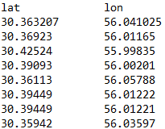

* graph_file_path : path of graph bz2 file that contains polygon graph file.
* output_file_path : path of output folium html file that contains routing visual on map.

## get_data :

this function gets the data and transform it to the geopandas dataframe with EPSG:4326 format.

## create_distance_matrix :

this function compute haversine distance matrix for cost coefficients.

## lp_model :

defines Lp minimization Problem with variables as edges and nodes. Then add distance costs.

then it defines the problem constraints as shown as below.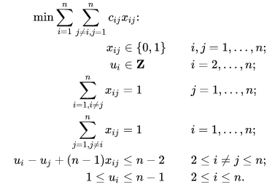

Then trys to solve it with simplex method and then it manipulate and gathers the answer up.

## get_routes_list :

this function first opens the graph file then using the output of Lp answers it trys to find the best path in the graph using network methods between each origins and destinations.It also calculates the total distance and duration.

## plot_data :

this functions trys to visualize the data and the output route using folium library and it creates html map file.

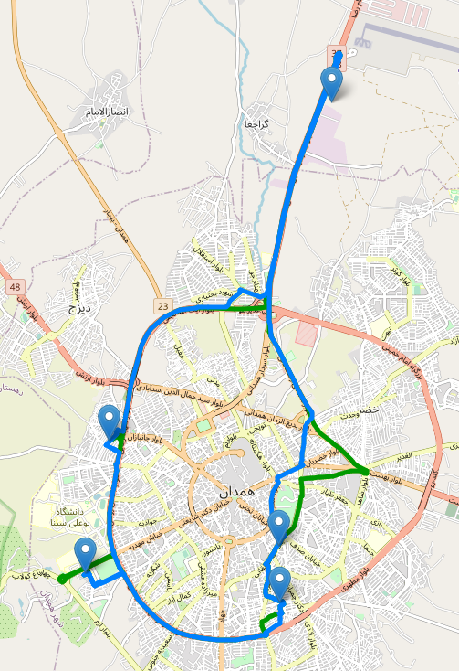

## Refrences :

<https://en.wikipedia.org/wiki/Travelling_salesman_problem>

<https://medium.com/swlh/techniques-for-subtour-elimination-in-traveling-salesman-problem-theory-and-implementation-in-71942e0baf0c>

<https://www.interviewbit.com/blog/travelling-salesman-problem/>

<https://www.tutorialspoint.com/design_and_analysis_of_algorithms/design_and_analysis_of_algorithms_travelling_salesman_problem.htm>

<https://www.frontiersin.org/articles/10.3389/frobt.2021.689908/full>